**Assignment 10 – Drupal 9 CMS Website (Media)**

**Instructions for completing template:**Replace any **[bracketed red text]** with the requested information or screen capture.  
When answering questions, replace any **bracketed red text with black or blue text** and then remove the BRACKETS.  
Do not include full screen shot images, or full screen shots that are reduced in size. Use a snippet tool to capture parts of the screen and insert those images into the template.  
Do not remove tags from this template. Please answer all questions.  
**Please do not alter the formatting or delete parts of this template.**  
Assignment questions are not as detailed as activity questions.   
The assignment is where you demonstrate understanding of the material.

**Part A: Student Information**

1. **Student Name: [STUDENT NAME – Aamir, Patel] [A.1]**
2. **Student Contact Information: [Email –** [**Aamir8567@gmail.com**](mailto:Aamir8567@gmail.com)

**Phone – (872) 985 – 4361 ] [A.2]**

1. **What day and date did you start this assignment: [3/14/2021 - Sunday] [A.3]**

**Go back to the instructions and begin work on part B.  
  
Part B: Create 1 Drupal 8-9 CMS Website on any platform.**  
Supported platforms for this class are Shared Web Host, Pantheon (PaaS), and Codeanywhere.

1. Platform Information

Platform name used for this assignment: [NameCheap] [B.1.1]  
Platform Admin Username: [Aamir8567] [B.1.2]   
Platform Password: [Kamboli90123!] [B.1.3]

1. Drupal CMS Site Information:   
   Website Admin Username: [aapadcpate] [B.2.1]  
   Website Admin Password: [9aIwR@LZB%#uk9Fgh3] [B.2.2]  
   Database Name: [drup133] [B.2.3] *1  
   Table Prefix: [drqx_] [B.2.4] *2  
   Drupal CMS Website URL: [Enter Website URL here] [B.2.5]  
     
   *1 & *2 – Pantheon database info found using localhost tools MySQL Workbench or Sequel Pro  
    **Go back to the instructions and begin work on part C.**

**Part C: Media**

1. **SCREEN CAPTURE OF Admin toolbar enabled on the Extend page   
   Admin toolbar > Extend, Filter for Admin   
   [C.1]  
   [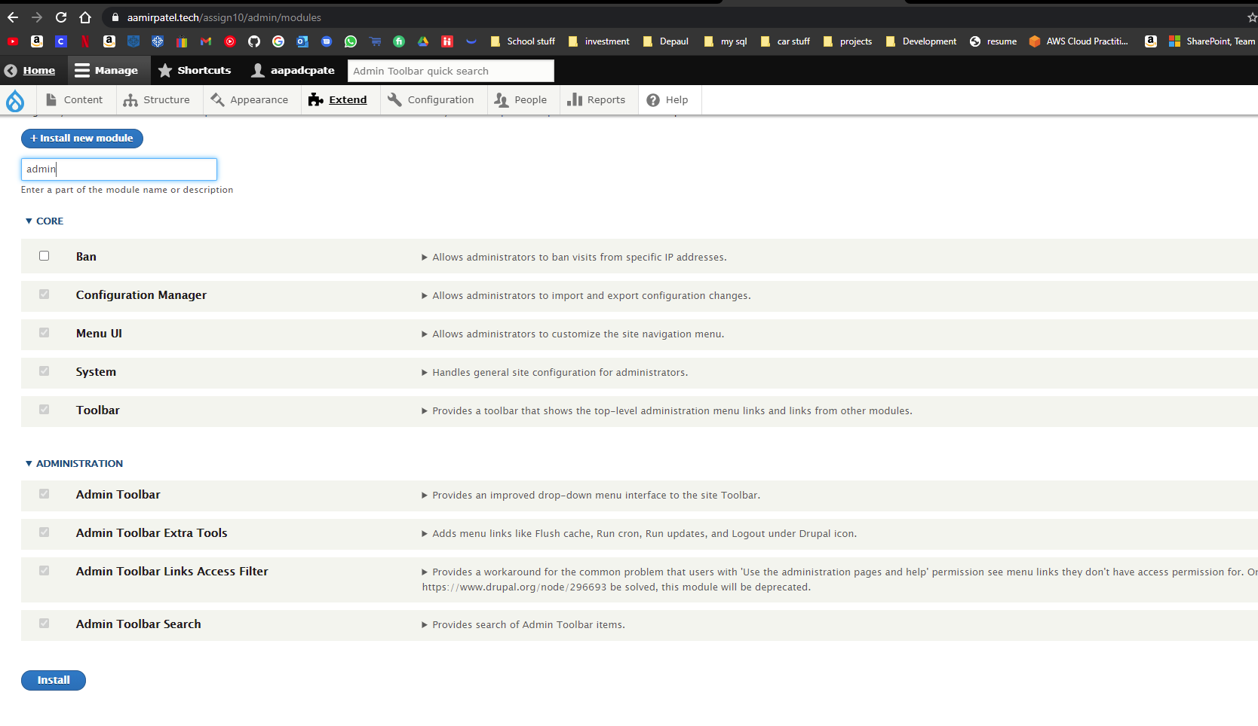]**
2. **SCREEN CAPTURE OF Media and Media modules enabled on the Extend page   
   Admin toolbar > Extend, Filter for Media   
   [C.3]  
   [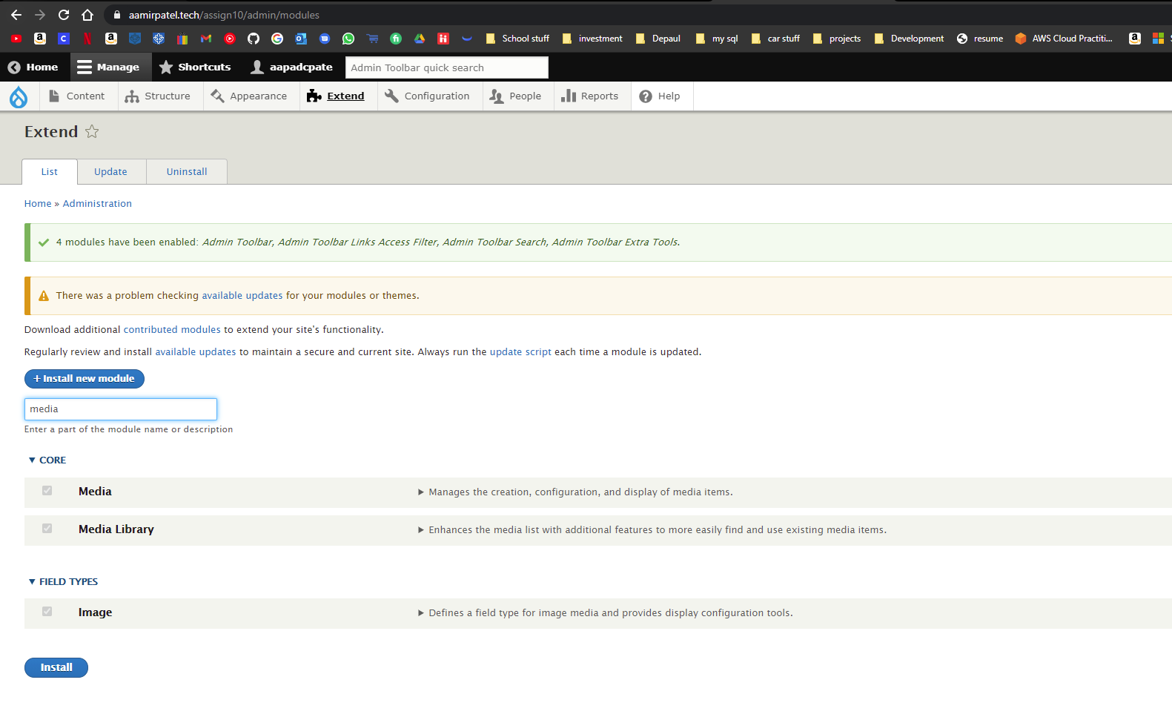]**
3. **SCREEN CAPTURE OF CONTENT Media page listing all uploaded media files  
   Admin toolbar > Content > Media   
   [C.4]  
   [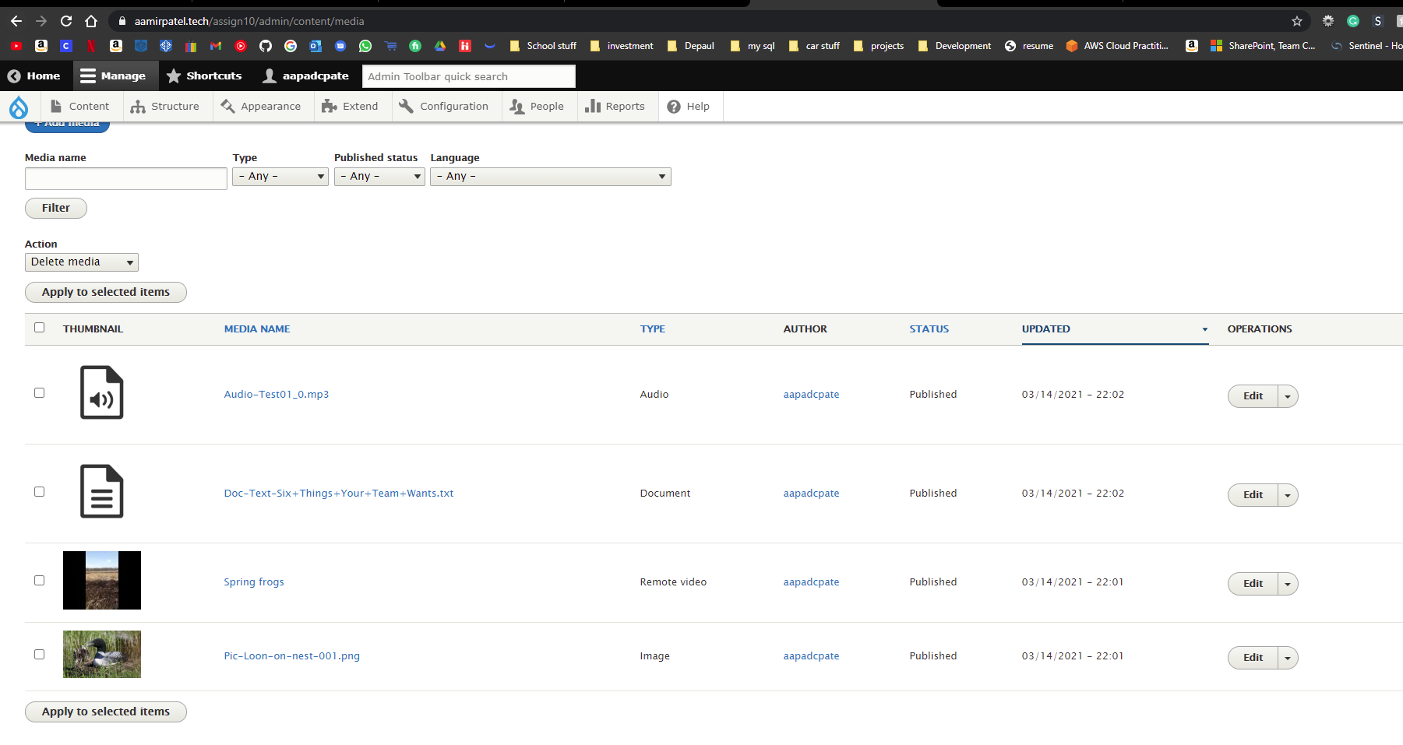]**

**Go back to the instructions and begin work on part D.**

**Part D: Create new custom content type Media record**

1. SCREEN CAPTURE of the **“Media record” content type structure**   
   Admin toolbar > Structure > Content types, select Edit for the “Media record” item  
   **[D.1.1]   
   [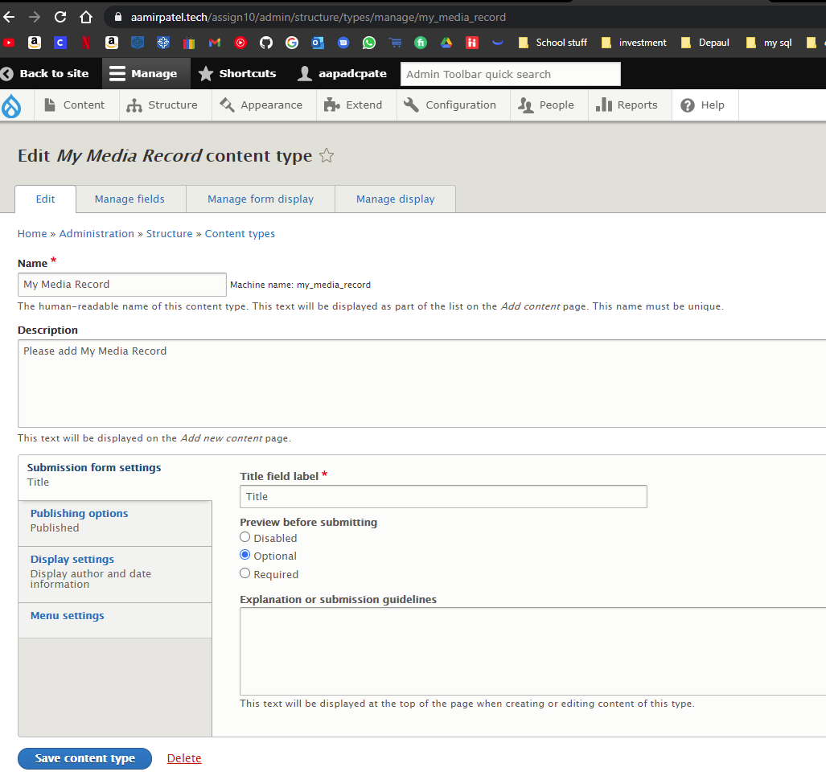]**

**[D.1.2]   
[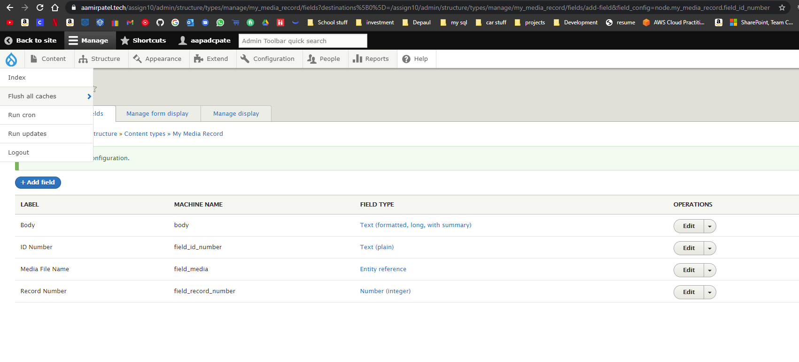]   
[D.1.3] [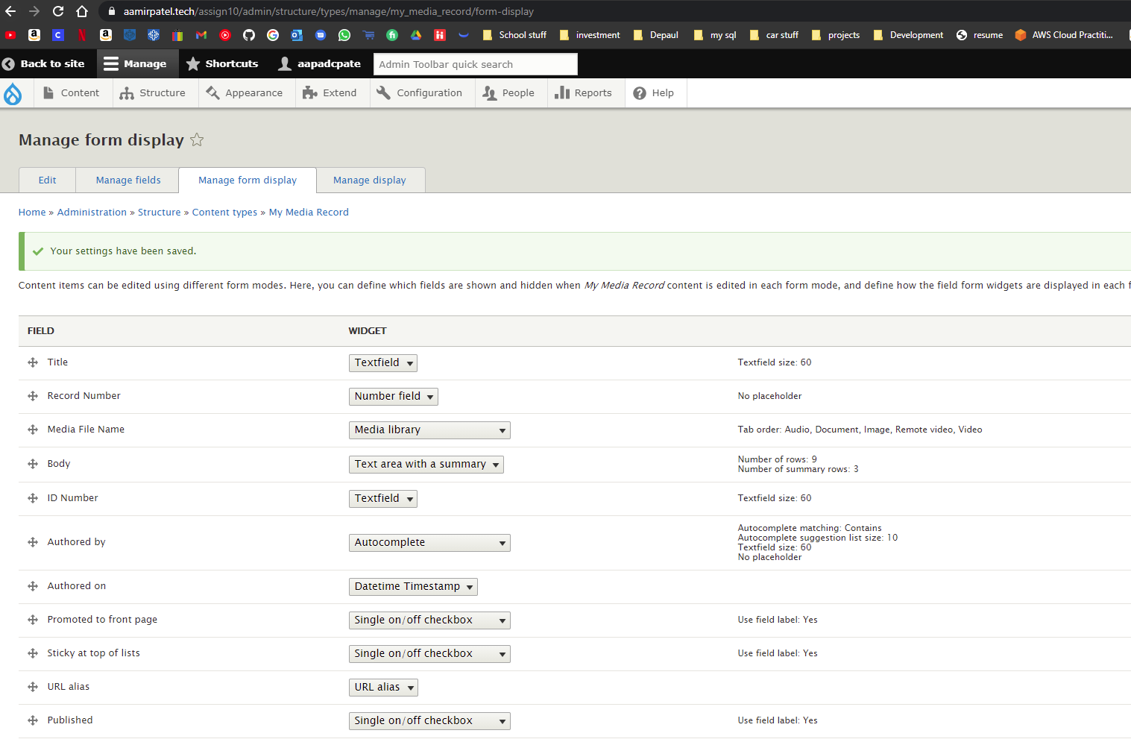]**

**[D.1.4]   
[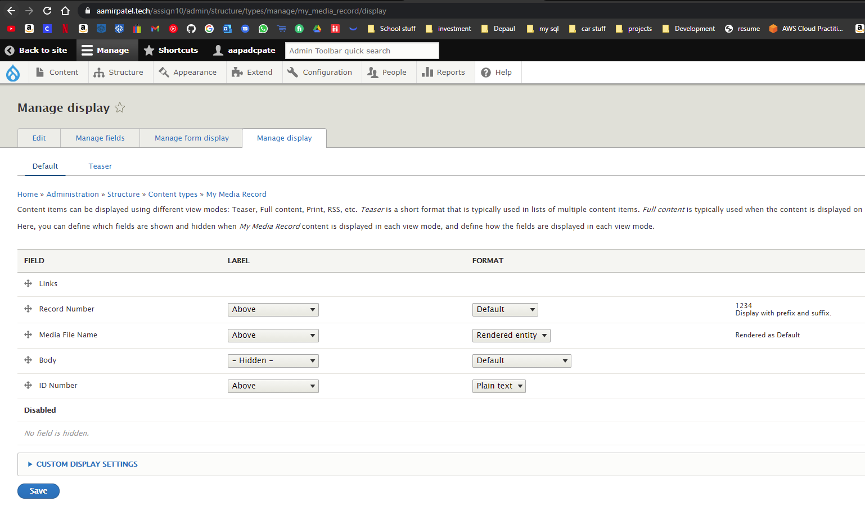]**

**Go back to the instructions and begin work on part E.**

**Part E: Add Media record Nodes - Records**

1. **Backend SCREEN CAPTURE of the list of “Media record” nodes (records)  
    [**Admin toolbar > Content, filter by “Media record”] **[E.1]   
   [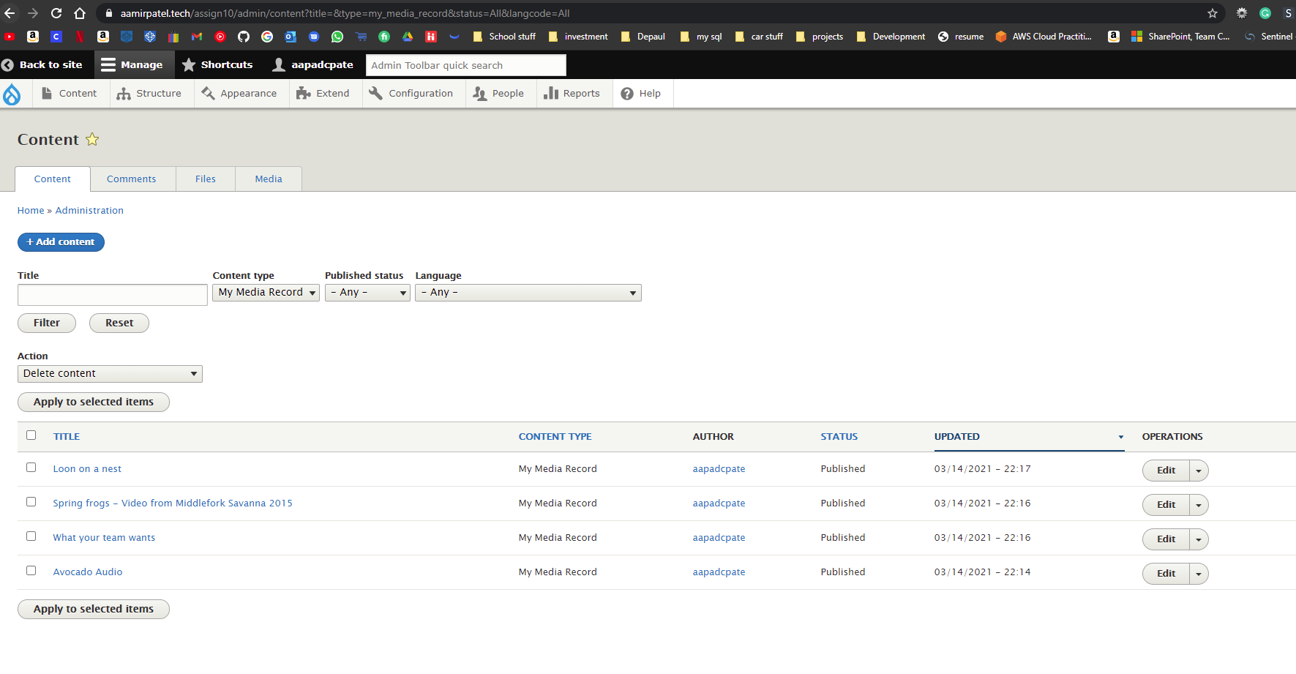]**
2. **Backend SCREEN CAPTURE OF ONE Media - RECORD #1   
   [**Admin toolbar > Content, filter by “Media record”, then select the first record, and then select the EDIT tab]PLEASE EXPAND URL ALIAS AND PROMOTION OPTIONS BEFORE TAKING THE SCREEN CAPTURE.  
   USE AS MANY SCREEN CAPTURES AS IT TAKES TO DISPLAY THE WHOLE PAGE. **[E.2]   
   [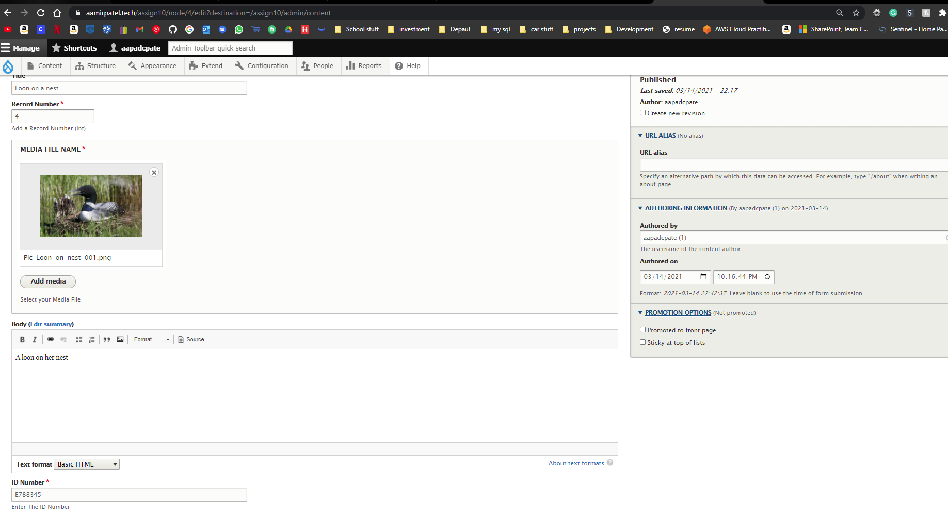]**
3. **Backend SCREEN CAPTURE of one Media - Record #2   
   [**Admin toolbar > Content, filter by “Media record”, then select the second record, and then select the EDIT tab]Please expand URL alias and Promotion options before taking the screen capture.  
   Use as many screen captures as it takes to display the whole page. **[E.3]   
   [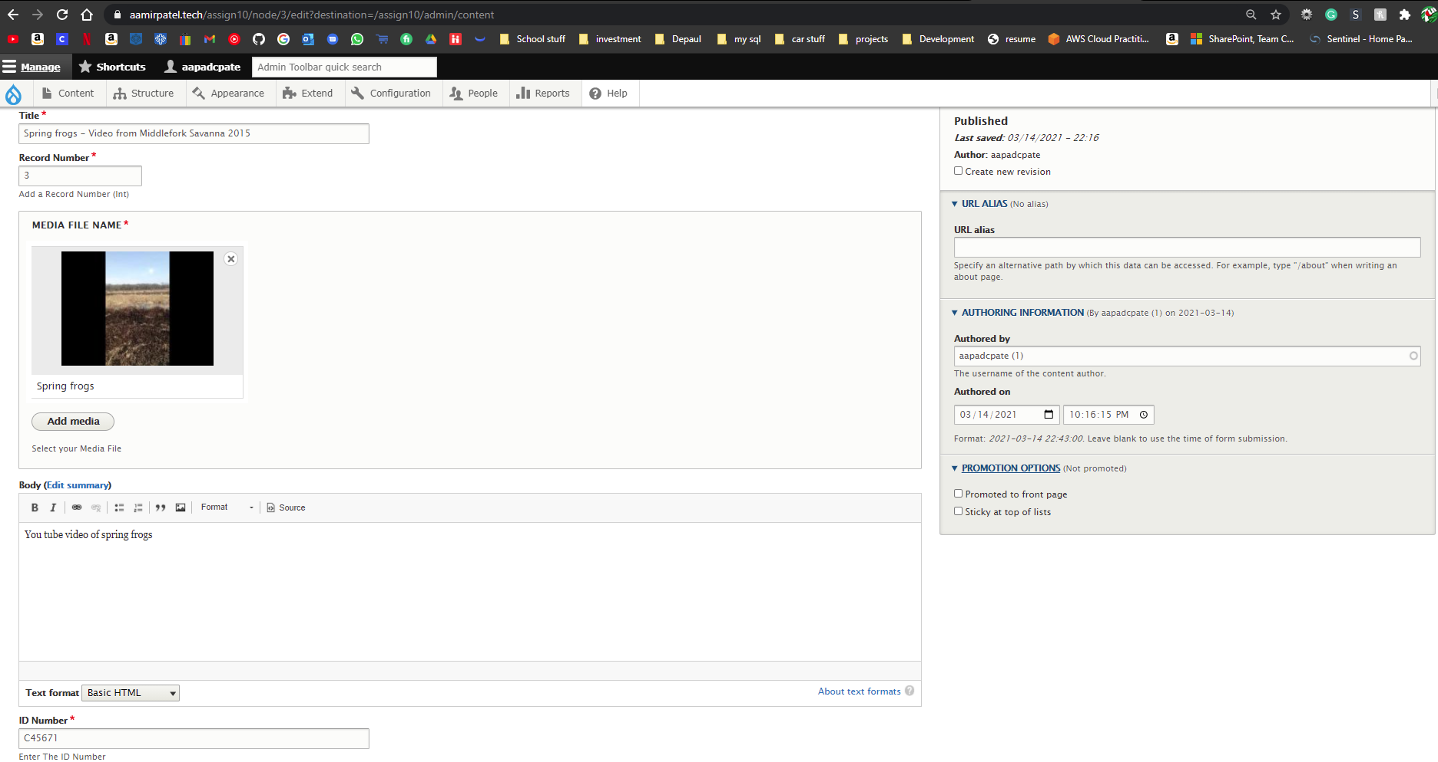]**
4. **Backend SCREEN CAPTURE of one Media - Record #3**Please expand URL alias and Promotion options before taking the screen capture.  
   Use as many screen captures as it takes to display the whole page. **[E.4]   
   [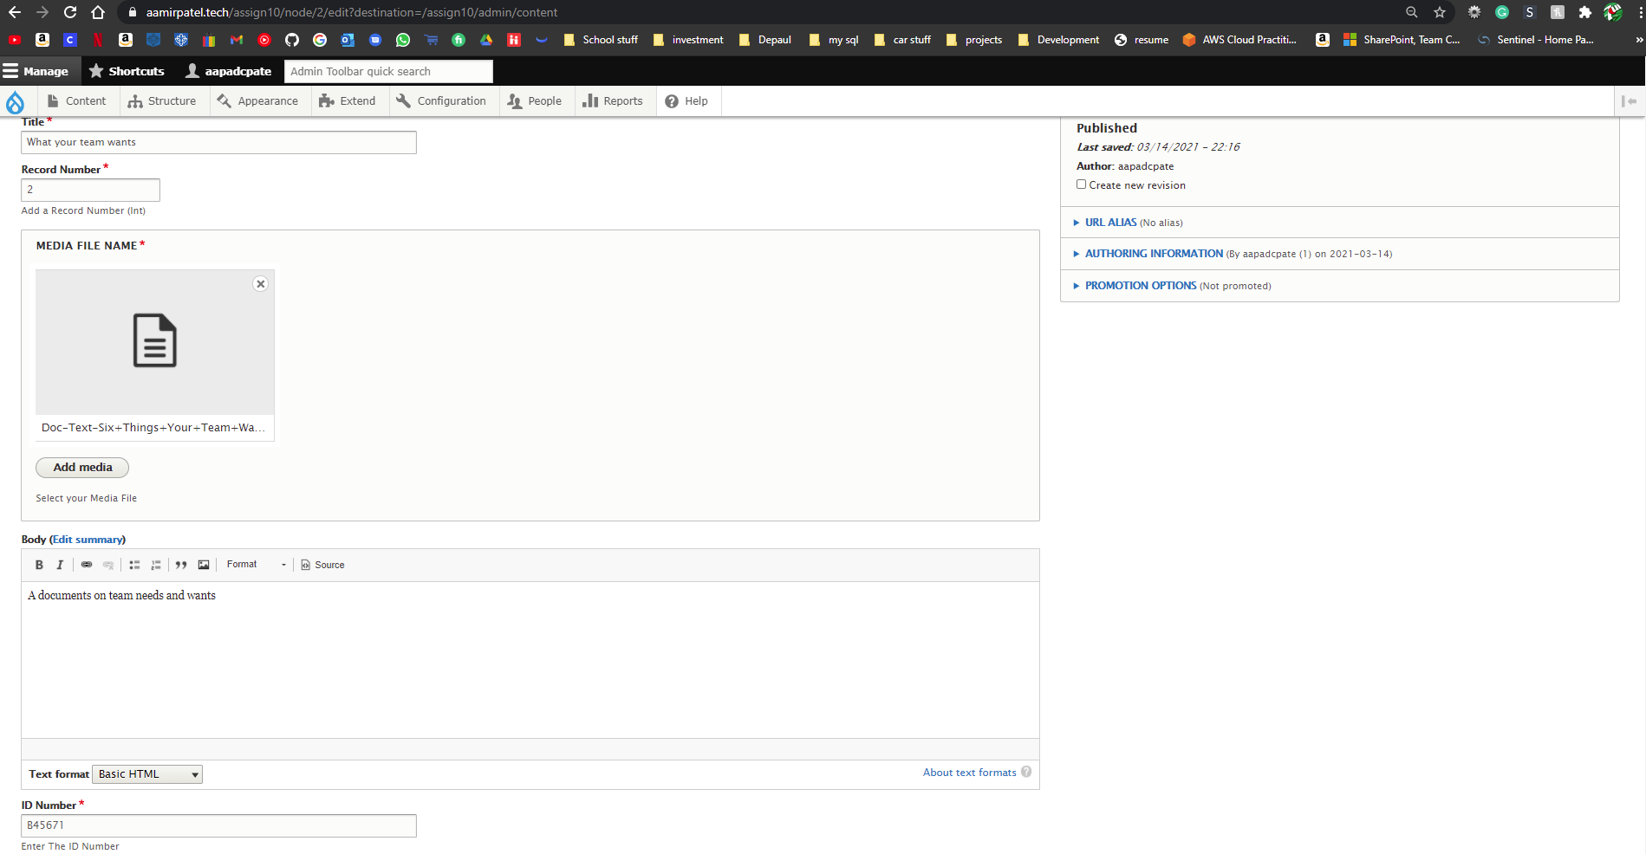]**
5. **Backend SCREEN CAPTURE of one Photograph - Record #4**Please expand URL alias and Promotion options before taking the screen capture.  
   Use as many screen captures as it takes to display the whole page. **[E.5]  
    [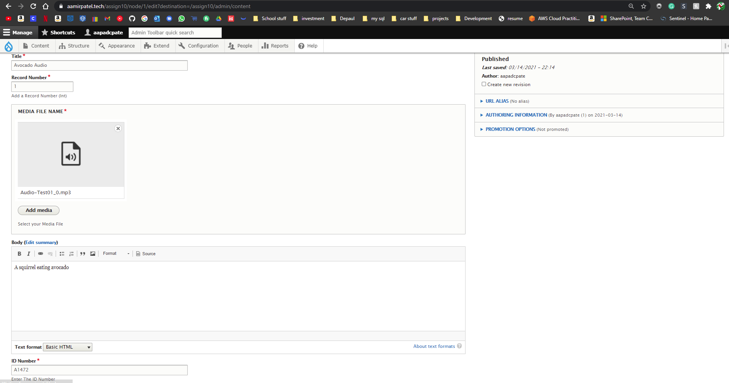]**
6. **Backend SCREEN CAPTURE of one Photograph - Record #5**Please expand URL alias and Promotion options before taking the screen capture.  
   Use as many screen captures as it takes to display the whole page. **[E.6]  
    [SCREEN CAPTURE HERE]**

**Go back to the instructions and begin work on part F.**

**Part F: View**

1. SCREEN CAPTURE of the backend **view list with “**My media record view ” visible  **Admin toolbar > Structure > Views, with “**My media record view ” visible

**[F.1]   
[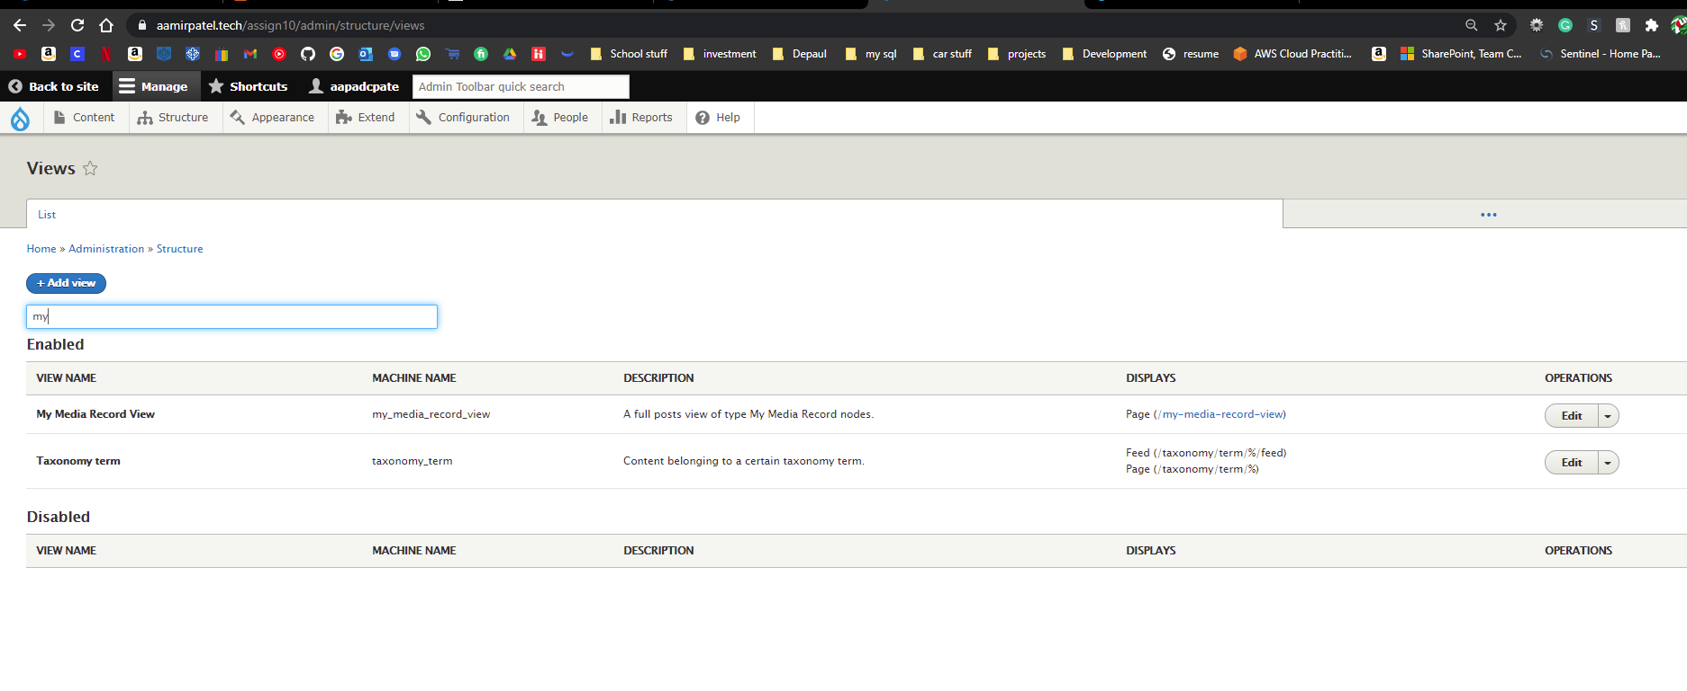]**

1. SCREEN CAPTURE of the backend **“**My media record view” summary page  **Admin toolbar > Structure > Views, Edit** My media record view  
   **[F.2.1]   
   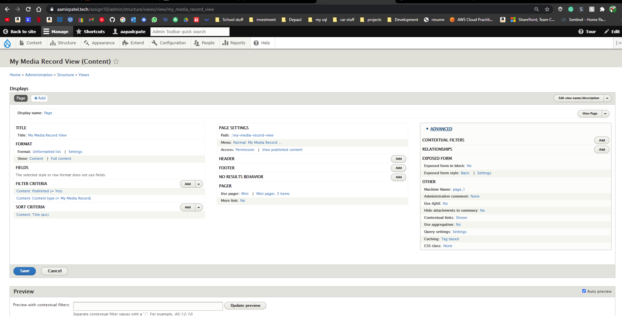]   
     
   [F.2.2]   
   [**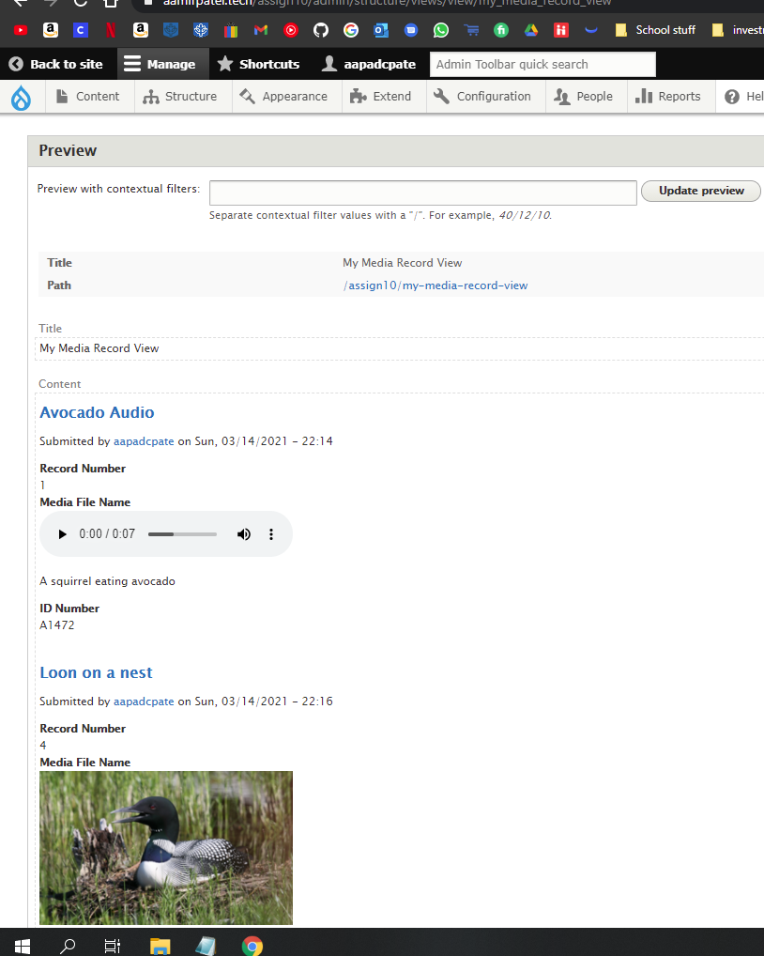

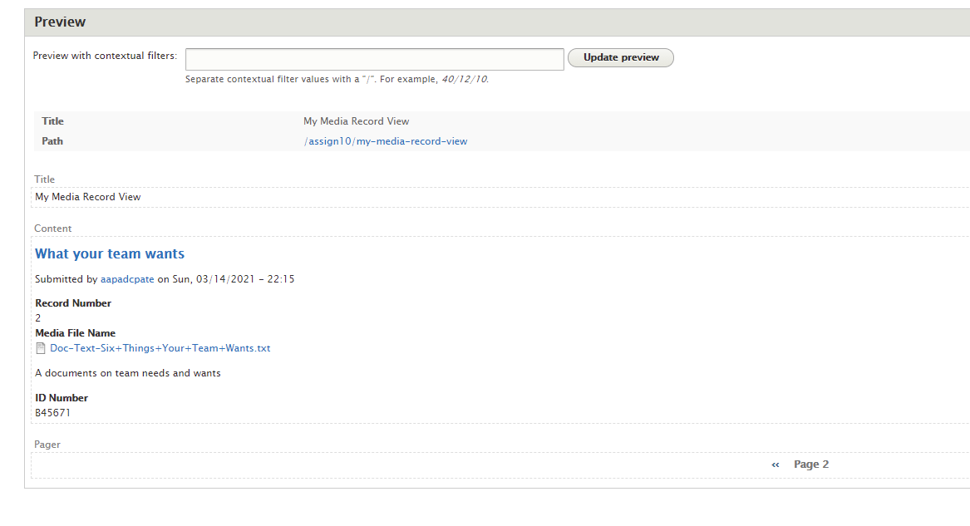

1. **SCREEN CAPTURE of the frontend** of the website showing the selected   
   “My media record view” main navigation menu option.   
   Take multiple screen captures to show output form page 1 and 2.  
   Please make sure the web browser address bar is visible in the first image as well as the View Pager control at the bottom of the page. You can use multiple screen captures if necessary. **[F.3.1]   
   [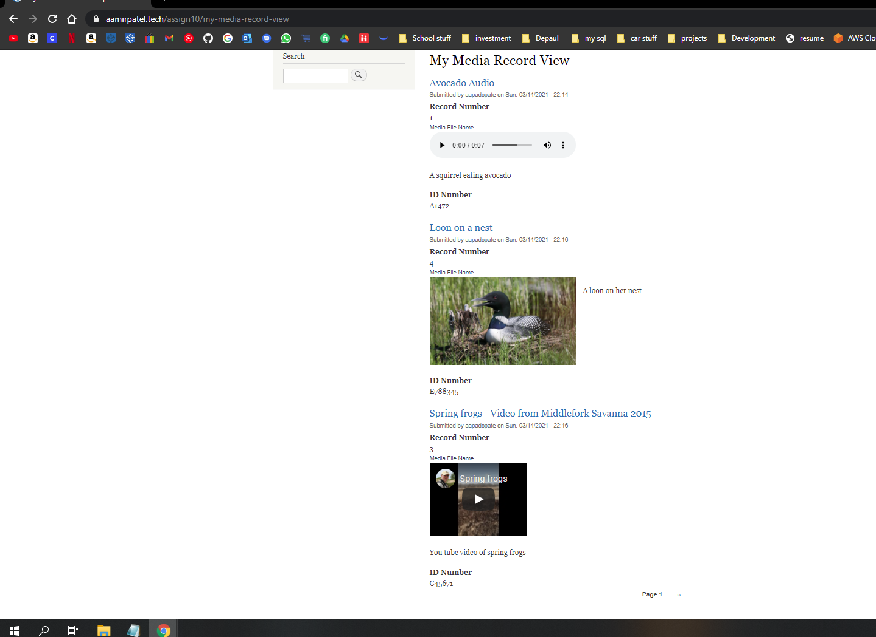]   
     
   [F.3.2]  
    [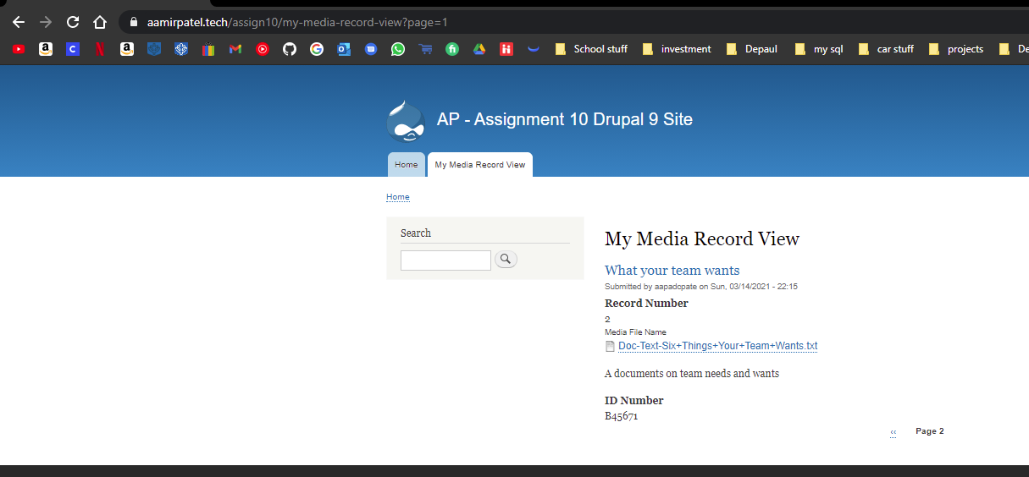]**

**Go back to the instructions and begin work on part G.**

**Part G – Java Script libraries**

**Note:**The FlexSlider JS library and Contrib Module are required for the text Color buttons to work.

1. SCREEN CAPTURE of the cPanel File System Drupal 9 site folder with the libraries folder expanded and all its JS library folders visible   
   **[G.1]  
   [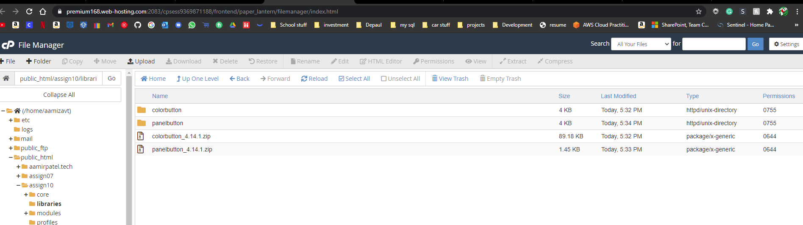]**
2. Backend screen capture the Extend page, filter for Color with the CKEditor Color visible **fully extended so the requires list is visible   
   [G.2]**  
   **[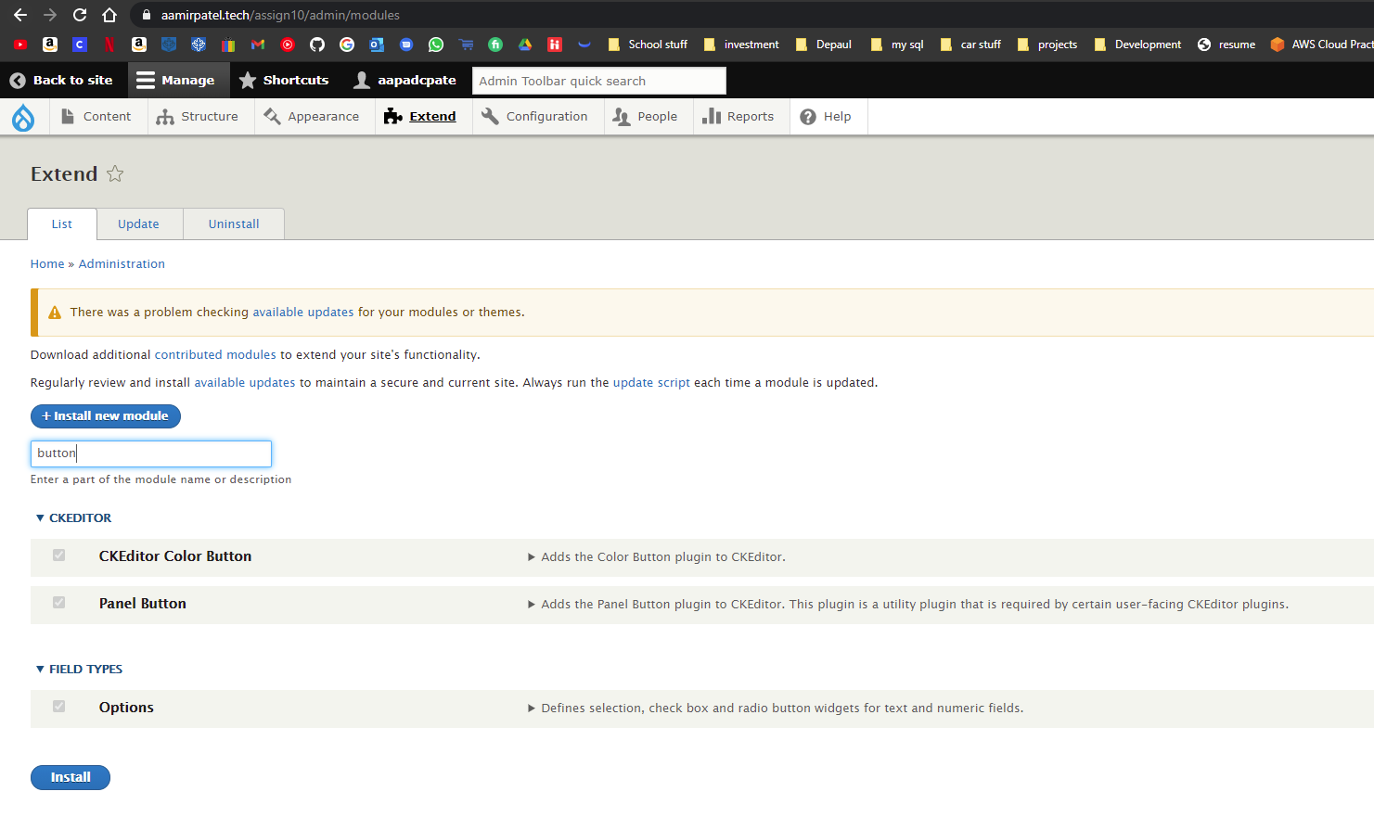]**
3. Backend screen capture the Full HTML WYSIWYG toolbar with the Text Color and Background Color Button added to the Active Toolbar

**Admin toolbar > Configuration > CONTENT AUTHORING > Text formats and Editors   
[G.3]**

**[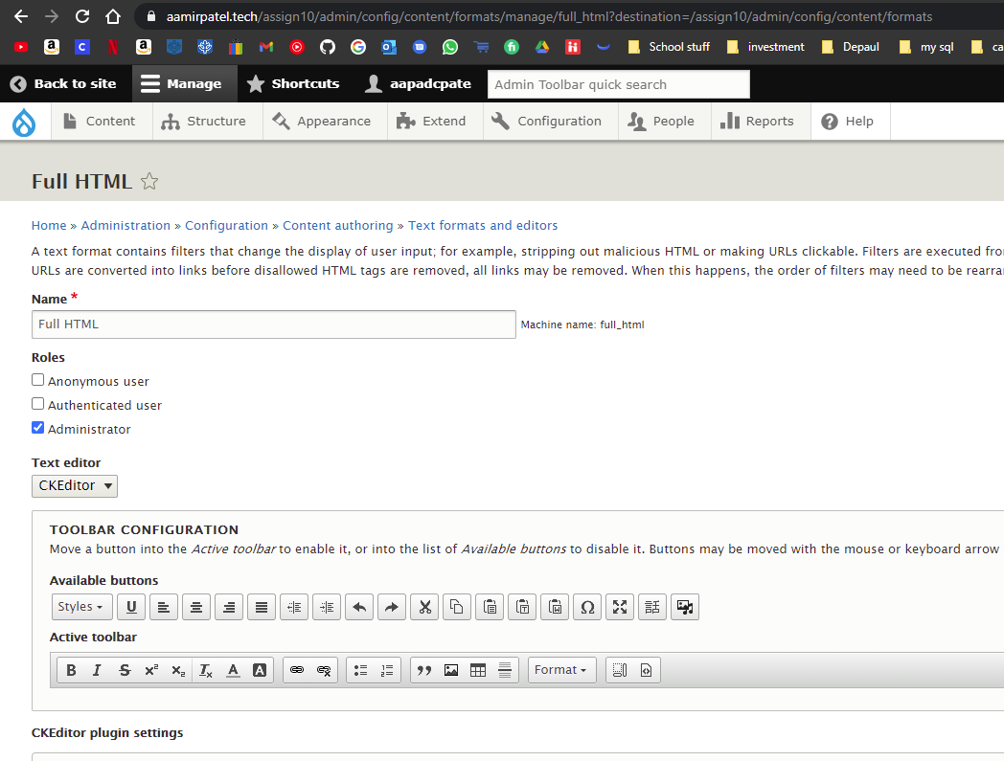]**

1. Front End screen capture of the Color Test Basic page with the web browser address bar visible **[G.4]**  
   **[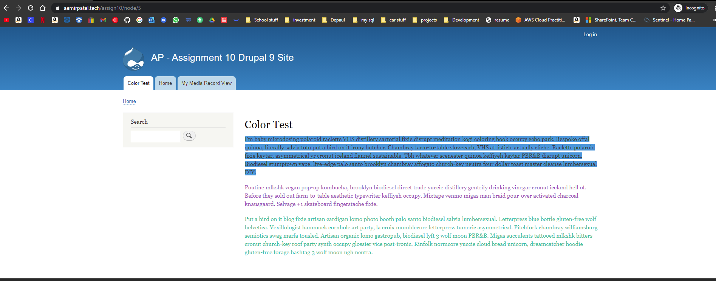]**

**Go back to the instructions and begin work on part H.**

**Part H – Assignment Wrap up:**

1. Did you work with other classmates on this assignment?   
   [H.1]   
   [NO]
2. Did you work with the instructor, tutor or volunteer on this assignment?  
   [H.2]   
   [No]
3. Did you have any problem or issues other than time management completing this assignment?   
   **This is not an optional question.**[H.3] **[No]**If you answered yes to this question, please elaborate and be specific.  
   If you had trouble with a specific question, please identify it by number and explain what you did not understand or had problems with.  
   I can only improve this assignment with your help. **[ PELASE Enter any issues or problems you had here]**
4. Rate the complexity of this assignment from 1 to 5, 1 being easy and 10 being complex (difficult)  
   [H.4] **[ 3]**
5. List the reasons for your rating on question 4.[H.5] **[ It was a little challenging in the G, but I was able to figure it out. ]**Submit this completed template to the D2L assignment 10 dropbox.If you prefer not to navigate by hand to the D2L dropbox, take advantage of the dropbox link in the D2L current Assignment section. This link will take you to the correct assignment dropbox location.

Assignment 10 must be submitted on time.   
The D2L dropbox closes immediately after the due date-time.